10-STEP PATTERN FOR SUCCESS

STEP 1. Set Your Goals
Have a dream and a burning desire for their achievement.
1.
2.
3.

STEP 2. Make a Commitment
Make a 12-month unconditional commitment to your PurpleUbusiness. The stronger your commitment level, the more likely you are to succeed.

STEP 3. Use the Products
You may gather detailed product information at http://www.yourdomainhere.com, from your sponsor and through conference calls. As the products and services start to work for you, simply share your testimonial with others.

STEP 4. Put together a Business Plan
Put your time commitment in writing.
Day of Week | Start Time | Finish Time | Total Hours
Sunday
Monday
Tuesday
Wednesday
Thursday
Friday
Saturday
Total Hours for Week
Record your income goals for your PurpleUbusiness. Make sure your income goals are consistent and realistic with your time commitment.
Time Period | Monthly Residual Income
6 Months
12 Months
24 Months

STEP 5. Learn the PurpleU Business Workflow

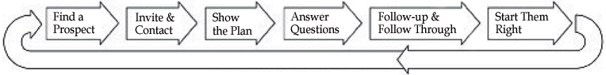

STEP 6. Use Your Upline
Record the contact information for three (3) upline team members to assist you in building your business. Use them regularly for, at minimum, your first 30 days.
Name | Phone Number | Email Address
1)
2)
3)

STEP 7. Learn About the Business Building Tools
As a PurpleU Business Member, you have many resources available to assist you in building your business. Learn to maximize your effectiveness using:
1. Your replicating http://www.yourdomainhere.com website | 4. Events
2. Live conference calls | 5.
3. Literature | 6.

STEP 8. Learn the Basics of the PurpleUCompensation Plan
Develop a basic understanding of the 5 different categories of income within PurpleU’s unique Compensation Plan.

STEP 9. Expose People to our Products and Opportunity
Learn the most effective ways to get a business tool into a prospect's hands.

STEP 10. Your First 30 Days
The first 30 days are the most important in launching your business. Record your personal sponsoring goal over the next 30 days.

I will personally sponsor ______ people in my first 30 days.

